**RED CABBAGE:-**

**NUTRINETS:-**

**Vitamin A**

**Folate**

**Vitamin B6**

**Vitamin E**

**Calcium** 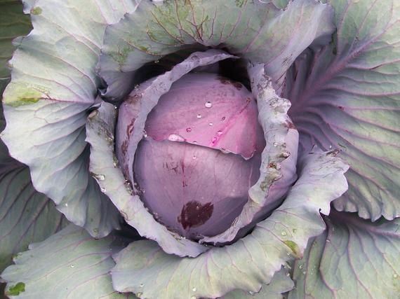

**Magnesium**

**Potassium**

**Manganese**

**Phosphorus**

**Zinc**

**Riboflavin**

**Thiamin**

**CLIMATE REQUIRED**

**temp=16 C to 20 C**

**rainfall= at least 500mm**

**avg rainy day(annualy)=.328**

**relative humid =80-90%**

**Where to grow:**

**Although cabbage can tolerate shade they will do much better in a sunny spot. Shelter is also beneficial. Avoid soil that becomes waterlogged or conversely dries out rapidly**.

**When to grow:**

**Red cabbages are normally sown February to mid April for transplanting from April to early June and cropping between August and November**.

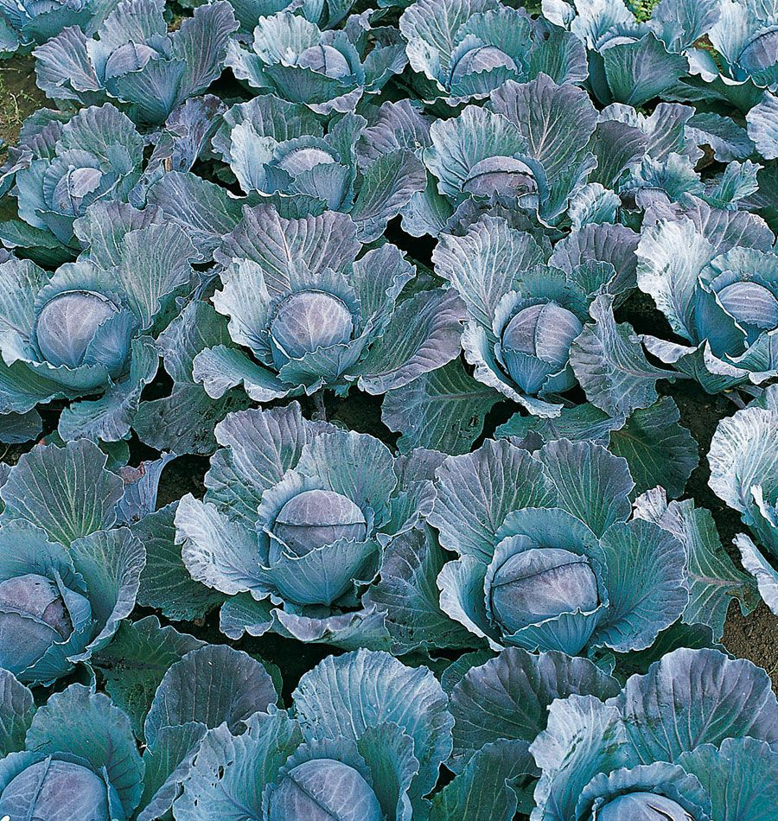

**PLANTING RED CABBAGE:**

**\*Once seedlings have been established and they've grown 2-3 true leaves, it's time to transplant your red cabbage!**

**\*Do this 2-3 weeks before the last expected frost date. If possible, transplant on a cloudy day so the seedling aren't exposed to intense sunlight.**

**\*Choose a good spot in your garden – raised beds are ideal, but not necessary.**

**\*An area with partial shade is best since red cabbage does love the sun, but cannot stand too much heat.**

**\*You can also plant red cabbage directly into pots so you can move the pots around.**

**\*Plant your red cabbage seedling into rich soil and scatter some organic material into the soil. Aged manure or compost will work well.**

**\*Make sure that the soil is well draining as cabbage cannot tolerate wet soil.**

**\*Plant 12-24 inches apart in rows. The closer you plant them, the smaller the cabbage heads.**

**\*Before planting outdoors, be sure to harden off the plants for about a week.**

**\*Add fertilizer once the plant has been stabilized.**

**\*You can grow cabbage alongside cucumbers and beans.**

**\*Since cabbage is closely related to broccoli and cauliflower, it's best not to plant them together as they are all heavy feeders and will compete for the nutrients.**

**\*It's also best not to plant cabbage alongside strawberries and tomatoes.**

**CARE:**

**Keep in partial sun.**

**Fertilize every few weeks.**

**Water regularly.**

**Keep free of weeds.**

**Keep an eye out for pests**.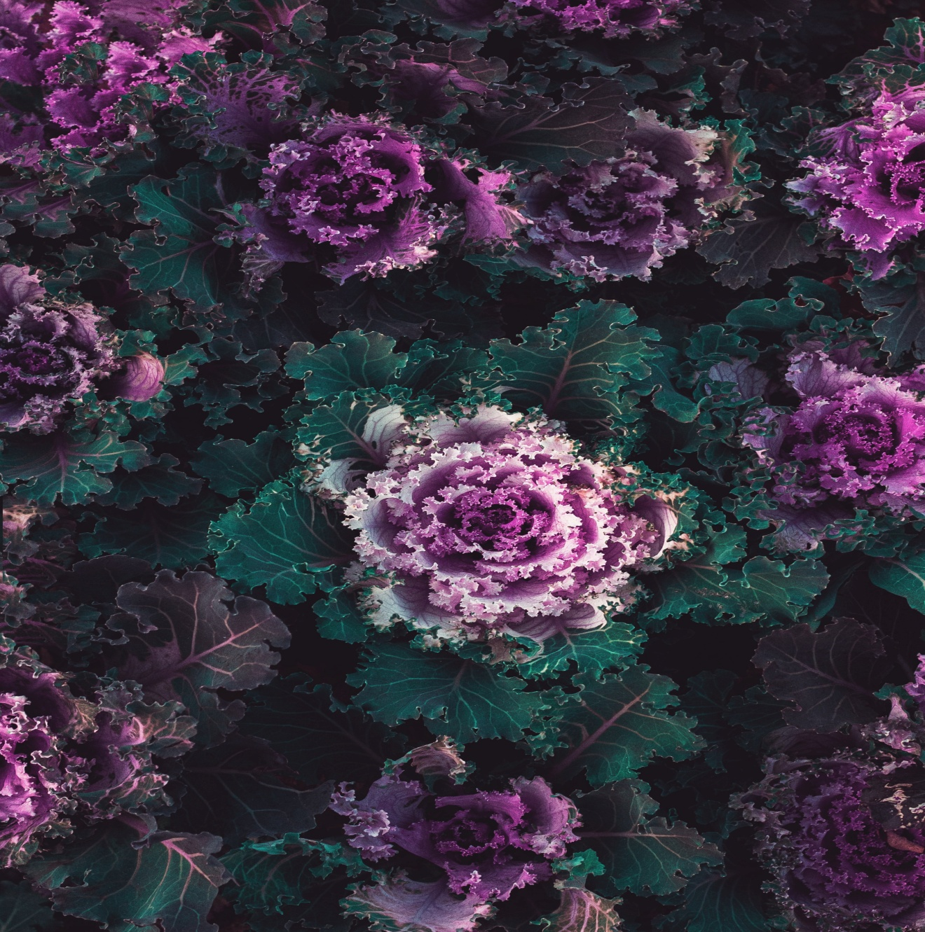

**HARVESTING RED CABBAGE:**

**\*Red cabbage is ready for harvest once they are big enough and have that deep, purple color.**

**\*Simply pull from the ground gently or use a sharp knife to cut at the bottom.**

**\*It will take about 70 days from planting to harvest.**

**\*To get two crops, cut the cabbage head off the plant and leave the outer leaves and root in the soil.**

**\*This will encourage the plant to grow new heads. Pinch them off until only 3 or 4 smaller heads remain.**

**\*After harvesting, be sure to remove entire root system to prevent soil borne diseases.**

**RED CABBAGE PESTS AND DISEASES:**

**\*Imported cabbageworms – plant dill near your cabbage plants to protect them from imported cabbageworms. This will attract beneficial wasps that will kill the cabbageworms and other pests.**

**\*Aphids**

**\*Cabbage root maggots**

**\*Flea beetles**

**\*Cutworms**

**\*Splitting**

**Related links:-**

<https://www.quickcrop.ie/learning/plant/red-cabbage#:~:text=Avoid%20soil%20that%20becomes%20waterlogged,cropping%20between%20August%20and%20November.&text=Transplant%20early%20cabbage%20soon%20enough,before%20the%20heat%20of%20summer>

**Youtube video:-**

1. [**https://youtu.be/janVeJvMXiw**](https://youtu.be/janVeJvMXiw)

**2.** [**https://youtu.be/Y1vS2g7Xhj0**](https://youtu.be/Y1vS2g7Xhj0)